Constructing Regular Hexagon

Definition
# Source: AI Source: Provided by: [Data Path: Persons Table -> ID Column: 1, Name_En Column: Motasem Essam] -> From: [ChatGPT] on [7/25/2026]
Constructing a Regular Hexagon is the geometric construction of a six-sided polygon in which all six sides are equal and all six interior angles are equal, using exact geometric methods, typically with a straightedge and compass.
For a regular hexagon $ABCDEF$:
$$\boxed{AB=BC=CD=DE=EF=FA}$$
and:
$$\boxed{∠A=∠B=∠C=∠D=∠E=∠F={120}^{∘}}$$
A regular hexagon has six equal central angles:
$$\boxed{{60}^{∘}}$$
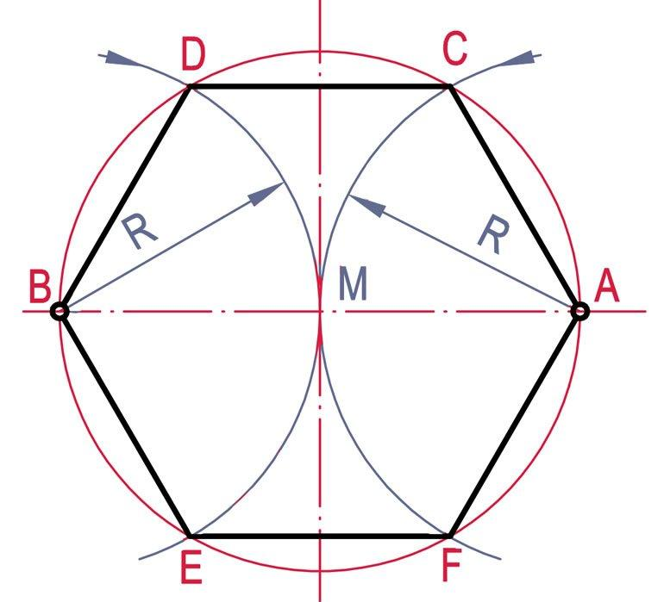
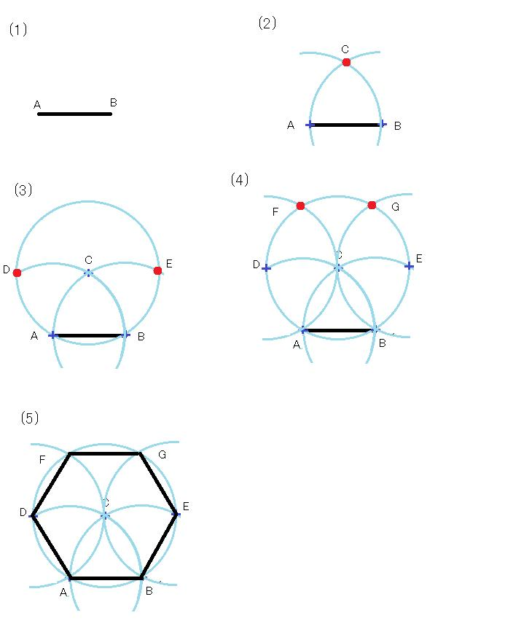
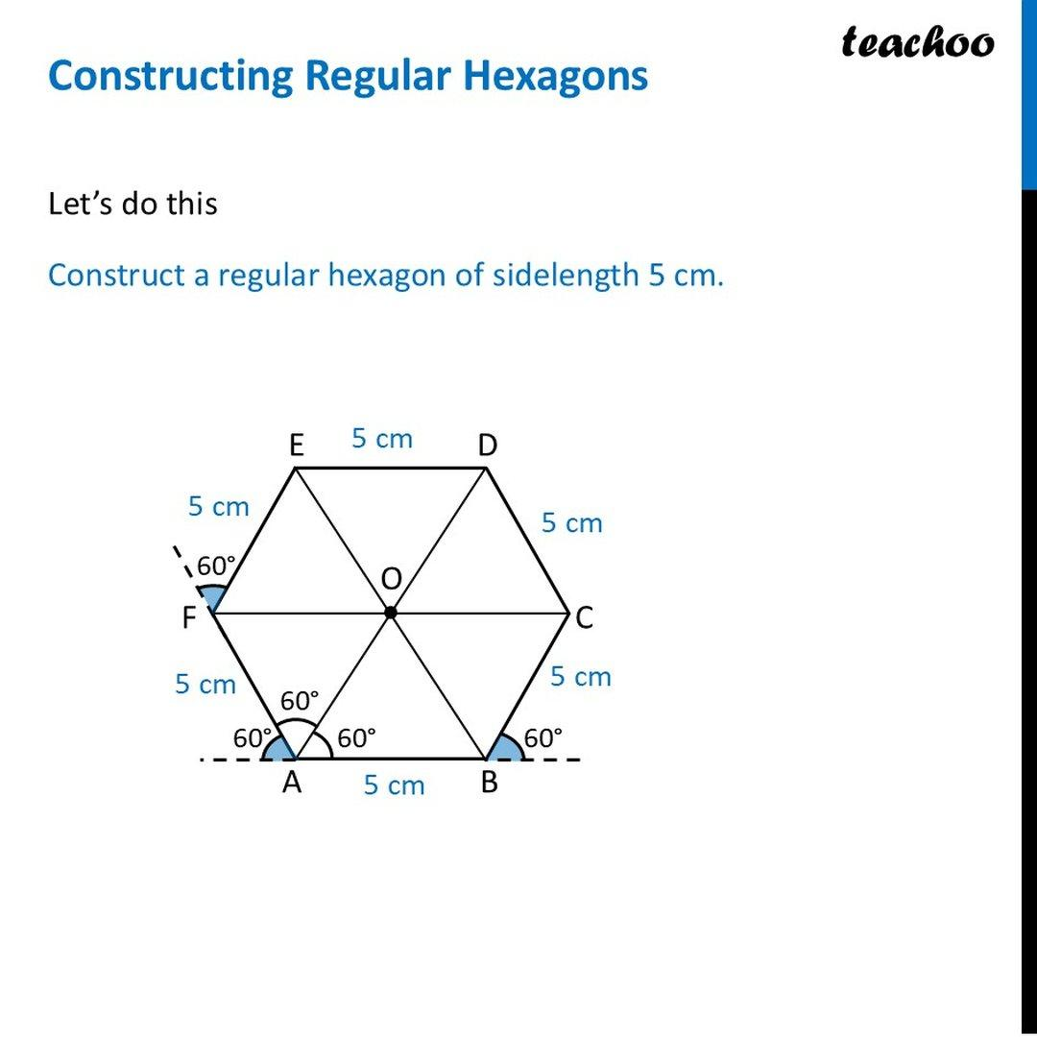
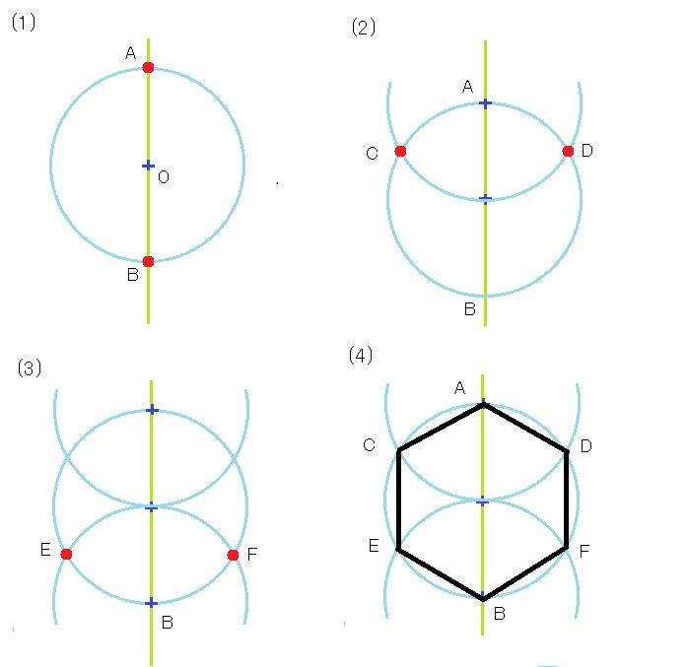

Fundamental Concept
# Source: AI Source: Provided by: [Data Path: Persons Table -> ID Column: 1, Name_En Column: Motasem Essam] -> From: [ChatGPT] on [7/25/2026]
A regular hexagon is a regular polygon with:
$$n=6$$
The sum of its interior angles is:
$$\left(6-2\right){180}^{∘}={720}^{∘}$$
Therefore, each interior angle is:
$$\frac{{720}^{∘}}{6}={120}^{∘}$$
Its central angle is:
$$\frac{{360}^{∘}}{6}={60}^{∘}$$
The most important property for construction is:
$$\boxed{\text{Side of an Inscribed Regular Hexagon}=\text{Radius of Its Circumcircle}}$$
This makes the regular hexagon particularly simple to construct with a compass.

Main Construction – From a Circumcircle
# Source: AI Source: Provided by: [Data Path: Persons Table -> ID Column: 1, Name_En Column: Motasem Essam] -> From: [ChatGPT] on [7/25/2026]
Suppose a circle with center $O$and radius $R$is given.
Construction Steps
- Construct or use the given circle with center $O$.
- Choose a point $A$on the circle.
- Set the compass opening to the radius:
$$OA$$
- Without changing the compass width, place the compass point at $A$.
- Draw an arc intersecting the circle at $B$.
- Move the compass point to $B$and mark $C$.
- Continue the same process to obtain:
$$D, E, F$$
- Finally, connect $F$to $A$.
The result is a regular hexagon.
The construction works because every side is a chord subtending a central angle of ${60}^{∘}$.
Thus:
$$\boxed{AB=BC=CD=DE=EF=FA=R}$$

Construction Using the Center and Radius
# Source: AI Source: Provided by: [Data Path: Persons Table -> ID Column: 1, Name_En Column: Motasem Essam] -> From: [ChatGPT] on [7/25/2026]
If the center $O$and radius $R$are given:
- Draw the circle centered at $O$.
- Mark any point $A$on the circle.
- Set the compass to $OA$.
- Step this same compass length around the circumference six times.
- Mark:
$$A,B,C,D,E,F$$
- Connect consecutive vertices.
This is the fundamental classical construction of a regular hexagon.

Construction Using a Given Side
# Source: AI Source: Provided by: [Data Path: Persons Table -> ID Column: 1, Name_En Column: Motasem Essam] -> From: [ChatGPT] on [7/25/2026]
If the side length $s$is given, construct a circle whose radius equals the side:
$$\boxed{R=s}$$
Steps
- Construct a segment of length $s$.
- Choose one endpoint as the center $O$.
- Draw a circle with radius $s$.
- Mark a point $A$on the circle.
- Set the compass to $s$.
- Step the compass around the circle six times.
- Connect the six points.
Therefore:
$$\boxed{s=R}$$
This equality is unique to the regular hexagon among the regular polygons in this particularly simple form.

Construction Using Central Angles
# Source: AI Source: Provided by: [Data Path: Persons Table -> ID Column: 1, Name_En Column: Motasem Essam] -> From: [ChatGPT] on [7/25/2026]
A regular hexagon divides a full circle into six equal central angles:
$$θ=\frac{{360}^{∘}}{6}={60}^{∘}$$
Therefore:
- Construct a circle.
- Mark its center $O$.
- Construct a ${60}^{∘}$central angle.
- Mark the first two vertices.
- Repeat the ${60}^{∘}$central angle around the circle.
- Obtain six equally spaced vertices.
- Connect consecutive vertices.
Thus:
$$\boxed{∠AOB=∠BOC=∠COD=∠DOE=∠EOF=∠FOA={60}^{∘}}$$

Construction Using a Diameter
# Source: AI Source: Provided by: [Data Path: Persons Table -> ID Column: 1, Name_En Column: Motasem Essam] -> From: [ChatGPT] on [7/25/2026]
A diameter can also be used to organize the construction.
- Construct a circle with center $O$.
- Draw a diameter $AD$.
- Construct a perpendicular diameter through $O$, producing points $B$and $E$.
- The remaining two vertices $C$and $F$are obtained by stepping the radius around the circle or by constructing the appropriate ${60}^{∘}$angles.
- Connect the six vertices.
This provides a useful framework for locating opposite vertices:
$$\boxed{A,D} \\ \boxed{B,E} \\ \boxed{C,F}$$
Each pair consists of opposite vertices.

Mathematical Properties
# Source: AI Source: Provided by: [Data Path: Persons Table -> ID Column: 1, Name_En Column: Motasem Essam] -> From: [ChatGPT] on [7/25/2026]
Number of Sides
$$\boxed{n=6}$$
Interior Angle
$$\boxed{{120}^{∘}}$$
Exterior Angle
$$\boxed{{60}^{∘}}$$
Central Angle
$$\boxed{{60}^{∘}}$$
Side Length
For a regular hexagon inscribed in a circle:
$$\boxed{s=R}$$
where $R$is the circumradius.
Perimeter
If each side has length $s$:
$$\boxed{P=6s}$$
Area
The hexagon can be divided into six equilateral triangles of side $s$.
Therefore:
$$\boxed{A=6\left(\frac{\sqrt{3}}{4}s^{2}\right)}$$
so:
$$\boxed{A=\frac{3\sqrt{3}}{2}s^{2}}$$
Apothem
The apothem is:
$$\boxed{a=\frac{\sqrt{3}}{2}s}$$
Therefore:
$$A=\frac{1}{2}Pa$$
gives:
$$A=\frac{1}{2}\left(6s\right)\left(\frac{\sqrt{3}}{2}s\right) \\ \boxed{A=\frac{3\sqrt{3}}{2}s^{2}}$$
Diagonals
A regular hexagon has three different diagonal lengths.
Short diagonal
Connecting vertices with one vertex between them:
$$\boxed{d_{1}=\sqrt{3}s}$$
Long diagonal
Connecting opposite vertices:
$$\boxed{d_{2}=2s}$$
The long diagonal is the diameter of the circumcircle:
$$\boxed{d_{2}=2R=2s}$$
Equilateral Triangle Relationship
A regular hexagon can be divided into six equilateral triangles by connecting its center to all six vertices.
Each triangle has:
$${60}^{∘}, {60}^{∘}, {60}^{∘}$$
and side length:
$$s$$
Therefore:
$$\boxed{\text{Regular Hexagon}=6\text{ Equilateral Triangles}}$$
This relationship explains why the side of the regular hexagon equals the circumradius.
Symmetry
A regular hexagon has:
- 6 lines of reflection symmetry
- 6-fold rotational symmetry
Its fundamental rotational symmetry angle is:
$$\boxed{{60}^{∘}}$$
The symmetry rotations include:
$${60}^{∘}, {120}^{∘}, {180}^{∘}, {240}^{∘}, {300}^{∘}, {360}^{∘}$$

Construction Situations
# Source: AI Source: Provided by: [Data Path: Persons Table -> ID Column: 1, Name_En Column: Motasem Essam] -> From: [ChatGPT] on [7/25/2026]
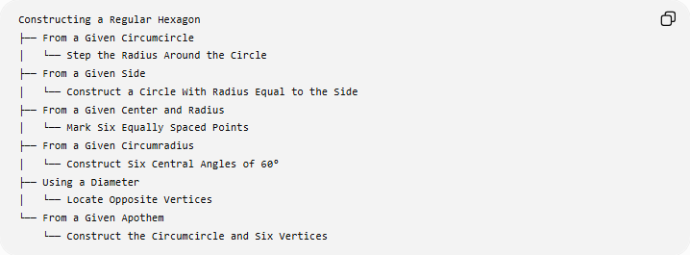
Constructing a Regular Hexagon
├── From a Given Circumcircle
│ └── Step the Radius Around the Circle
├── From a Given Side
│ └── Construct a Circle With Radius Equal to the Side
├── From a Given Center and Radius
│ └── Mark Six Equally Spaced Points
├── From a Given Circumradius
│ └── Construct Six Central Angles of 60°
├── Using a Diameter
│ └── Locate Opposite Vertices
└── From a Given Apothem
└── Construct the Circumcircle and Six Vertices
These are construction situations based on the given information, rather than different mathematical types of regular hexagons.

Basic Constructions Used
# Source: AI Source: Provided by: [Data Path: Persons Table -> ID Column: 1, Name_En Column: Motasem Essam] -> From: [ChatGPT] on [7/25/2026]
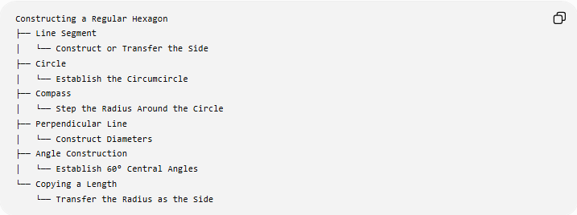
Constructing a Regular Hexagon
├── Line Segment
│ └── Construct or Transfer the Side
├── Circle
│ └── Establish the Circumcircle
├── Compass
│ └── Step the Radius Around the Circle
├── Perpendicular Line
│ └── Construct Diameters
├── Angle Construction
│ └── Establish 60° Central Angles
└── Copying a Length
└── Transfer the Radius as the Side

Regular Hexagon and Its Circumcircle
# Source: AI Source: Provided by: [Data Path: Persons Table -> ID Column: 1, Name_En Column: Motasem Essam] -> From: [ChatGPT] on [7/25/2026]
For a regular hexagon $ABCDEF$inscribed in a circle with center $O$:
$$OA=OB=OC=OD=OE=OF=R$$
and:
$$AB=BC=CD=DE=EF=FA=R$$
Therefore:
$$\boxed{\text{Side Length}=\text{Circumradius}}$$
This is the fundamental geometric relationship used in the classical construction.

Regular Hexagon vs Irregular Hexagon
# Source: AI Source: Provided by: [Data Path: Persons Table -> ID Column: 1, Name_En Column: Motasem Essam] -> From: [ChatGPT] on [7/25/2026]
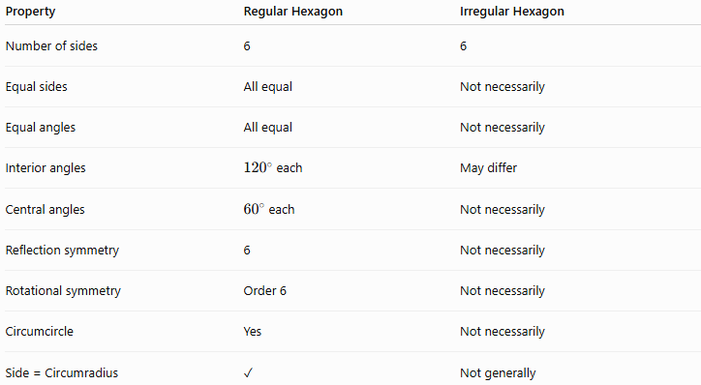
Property | Regular Hexagon | Irregular Hexagon
Number of sides | 6 | 6
Equal sides | All equal | Not necessarily
Equal angles | All equal | Not necessarily
Interior angles | ${120}^{∘}$each | May differ
Central angles | ${60}^{∘}$each | Not necessarily
Reflection symmetry | 6 | Not necessarily
Rotational symmetry | Order 6 | Not necessarily
Circumcircle | Yes | Not necessarily
Side = Circumradius | ✓ | Not generally

Regular Hexagon vs Other Regular Polygons
# Source: AI Source: Provided by: [Data Path: Persons Table -> ID Column: 1, Name_En Column: Motasem Essam] -> From: [ChatGPT] on [7/25/2026]
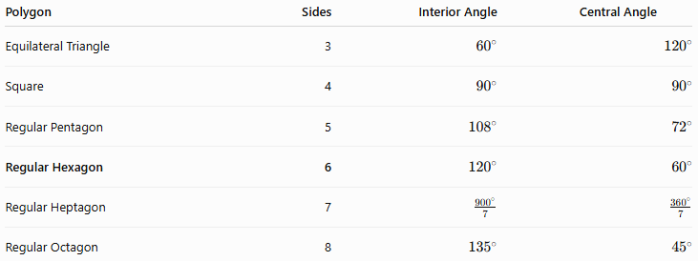
Polygon | Sides | Interior Angle | Central Angle
Equilateral Triangle | 3 | $${60}^{∘}$$ | $${120}^{∘}$$
Square | 4 | $${90}^{∘}$$ | $${90}^{∘}$$
Regular Pentagon | 5 | $${108}^{∘}$$ | $${72}^{∘}$$
Regular Hexagon | 6 | $${120}^{∘}$$ | $${60}^{∘}$$
Regular Heptagon | 7 | $$\frac{{900}^{∘}}{7}$$ | $$\frac{{360}^{∘}}{7}$$
Regular Octagon | 8 | $${135}^{∘}$$ | $${45}^{∘}$$

Classification
# Source: AI Source: Provided by: [Data Path: Persons Table -> ID Column: 1, Name_En Column: Motasem Essam] -> From: [ChatGPT] on [7/25/2026]
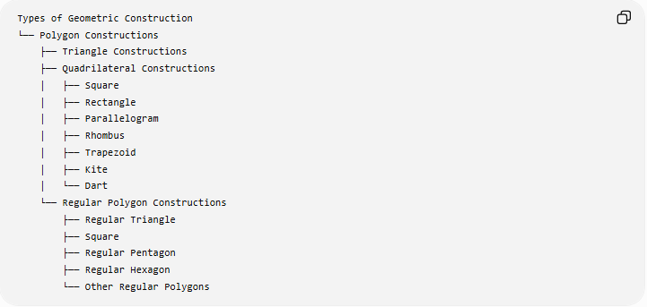
Types of Geometric Construction
└── Polygon Constructions
├── Triangle Constructions
├── Quadrilateral Constructions
│ ├── Square
│ ├── Rectangle
│ ├── Parallelogram
│ ├── Rhombus
│ ├── Trapezoid
│ ├── Kite
│ └── Dart
└── Regular Polygon Constructions
├── Regular Triangle
├── Square
├── Regular Pentagon
├── Regular Hexagon
└── Other Regular Polygons
Detailed Classification
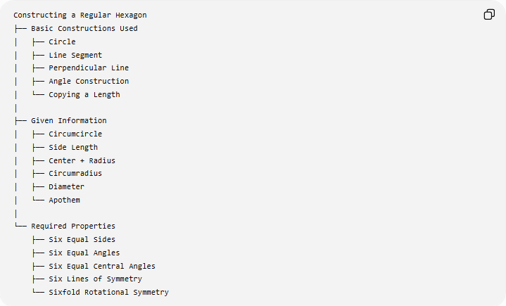
Constructing a Regular Hexagon
├── Basic Constructions Used
│ ├── Circle
│ ├── Line Segment
│ ├── Perpendicular Line
│ ├── Angle Construction
│ └── Copying a Length
│
├── Given Information
│ ├── Circumcircle
│ ├── Side Length
│ ├── Center + Radius
│ ├── Circumradius
│ ├── Diameter
│ └── Apothem
│
└── Required Properties
├── Six Equal Sides
├── Six Equal Angles
├── Six Equal Central Angles
├── Six Lines of Symmetry
└── Sixfold Rotational Symmetry

Key Points
# Source: AI Source: Provided by: [Data Path: Persons Table -> ID Column: 1, Name_En Column: Motasem Essam] -> From: [ChatGPT] on [7/25/2026]
- A regular hexagon has exactly 6 equal sides.
- It has 6 equal interior angles:
$${120}^{∘}$$
- Its central and exterior angles are:
$${60}^{∘}$$
- The side of an inscribed regular hexagon equals the circumradius:
$$\boxed{s=R}$$
- It can be constructed by simply stepping the radius around a circle six times.
- It can be divided into six equilateral triangles.
- Its area is:
$$\boxed{A=\frac{3\sqrt{3}}{2}s^{2}}$$
- Its perimeter is:
$$\boxed{P=6s}$$
- It has 6 lines of reflection symmetry.
- It has rotational symmetry of order 6.
- Its longest diagonal equals the diameter:
$$\boxed{d=2s}$$

Conclusion
# Source: AI Source: Provided by: [Data Path: Persons Table -> ID Column: 1, Name_En Column: Motasem Essam] -> From: [ChatGPT] on [7/25/2026]
Constructing a Regular Hexagon is the exact construction of a six-sided regular polygon using a particularly simple relationship between a circle and its radius. When a circumcircle is given, the compass can be set to the radius and that same length can be stepped around the circumference exactly six times. This works because:
$$\boxed{\text{Side Length}=\text{Circumradius}}$$
The regular hexagon is also naturally related to the equilateral triangle because it can be divided into six equilateral triangles. Its ${60}^{∘}$central angles, ${120}^{∘}$interior angles, six equal sides, and sixfold symmetry make it one of the fundamental regular polygon constructions.

